Packet Tracer – Skills Integration Challenge

1. Topology

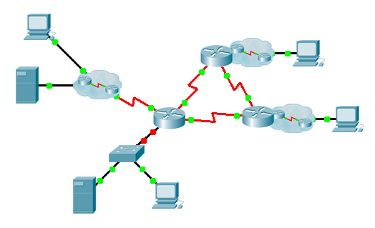

1. Addressing Table

|  |  |  |  |  |
| --- | --- | --- | --- | --- |
| Device | Interface | IP Address | Subnet Mask | Default Gateway |
|  | G0/0.15 |  |  | N/A |
| G0/0.30 |  |  | N/A |
| G0/0.45 |  |  | N/A |
| G0/0.60 |  |  | N/A |
| S0/0/0 |  | 255.255.255.252 | N/A |
| S0/0/1 |  | 255.255.255.252 | N/A |
| S0/1/0 |  | 255.255.255.252 | N/A |
|  | G0/0 |  |  | N/A |
| S0/0/0 |  | 255.255.255.252 | N/A |
| S0/0/1 |  | 255.255.255.252 | N/A |
|  | G0/0 |  |  | N/A |
| S0/0/0 |  | 255.255.255.252 | N/A |
| S0/0/1 |  | 255.255.255.252 | N/A |
|  | VLAN 60 |  |  |  |
|  | NIC | DHCP Assigned | DHCP Assigned | DHCP Assigned |

1. VLANs and Port Assignments Table

|  |  |  |
| --- | --- | --- |
| VLAN Number - Name | Port assignment | Network |
| 15 - Servers | F0/11 - F0/20 |  |
| 30 - PCs | F0/1 - F0/10 |  |
| 45 - Native | G1/1 |  |
| 60 - Management | VLAN 60 |  |

1. Scenario

This activity includes many of the skills that you have acquired during your CCNA studies. First, you will complete the documentation for the network. So make sure you have a printed version of the instructions. During implementation, you will configure VLANs, trunking, port security and SSH remote access on a switch. Then, you will implement inter-VLAN routing and NAT on a router. Finally, you will use your documentation to verify your implementation by testing end-to-end connectivity.

1. Documentation

You are required to fully document the network. You will need a print out of this instruction set, which will include an unlabeled topology diagram:

* 1. Label all the device names, network addresses and other important information that Packet Tracer generated.
  2. Complete the **Addressing Table** and **VLANs and Port Assignments Table**.
  3. Fill in any blanks in the **Implementation** and **Verification** steps. The information is supplied when you launch the Packet Tracer activity.

1. Implementation

Note: All devices in the topology except **______________**, **______________**, and **______________** are fully configured. You do not have access to the other routers. You can access all the servers and PCs for testing purposes.

Implement to following requirements using your documentation:

**______________**

* Configure remote management access including IP addressing and SSH:
  1. Domain is cisco.com
  2. User **______________** with password **______________**
  3. Crypto key length of 1024
  4. SSH version 2, limited to 2 authentication attempts and a 60 second timeout
  5. Clear text passwords should be encrypted.
* Configure, name and assign VLANs. Ports should be manually configured as access ports.
* Configure trunking.
* Implement port security:
  1. On Fa0/1, allow 2 MAC addresses that are automatically added to the configuration file when detected. The port should not be disabled, but a syslog message should be captured if a violation occurs.
  2. Disable all other unused ports.

______________

* Configure inter-VLAN routing.
* Configure DHCP services for VLAN 30. Use **LAN** as the case-sensitive name for the pool.
* Implement routing:
  1. Use OSPF process ID 1 and router ID 1.1.1.1
  2. Configure one network statement for the entire **______________** address space
  3. Disable interfaces that should not send OSPF messages.
  4. Configure a default route to the Internet.
* Implement NAT:
  1. Configure a standard, one statement ACL number 1. All IP addresses belonging to the **______________** address space are allowed.
  2. Refer to your documentation and configure static NAT for the File Server.
  3. Configure dynamic NAT with PAT using a pool name of your choice, a /30 mask, and these two public addresses:
     1. **______________**

______________

Verify **______________** has received full addressing information from **______________**.

1. Verification

All devices should now be able to ping all other devices. If not, troubleshoot your configurations to isolate and solve problems. A few tests include:

* Verify remote access to **______________** by using SSH from a PC.
* Verify VLANs are assigned to appropriate ports and port security is in force.
* Verify OSPF neighbors and a complete routing table.
* Verify NAT translations and statics.
  1. **Outside Host** should be able to access **File Server** at the public address.
  2. Inside PCs should be able to access **Web Server**.
* Document any problems you encountered and the solutions in the **Troubleshooting Documentation** table below.

1. Troubleshooting Documentation

|  |  |
| --- | --- |
| Problem | Solution |
|  |  |
|  |  |
|  |  |
|  |  |

1. Suggested Scoring Rubric

Packet Tracer scores 70 points. Documentation is worth 30 points.